**Format for uploading details in Github and Slack in word file format**

**Student Name : Shrinivasa**

**Class and Sec : VI B**

**USN : 4AL17CS092**

|  |  |  |  |  |
| --- | --- | --- | --- | --- |
| **Online Test Details** | | | | |
| **Subject** | **System Software and Compiler Design** | | | |
| **Semester** | **VI - B** | | **Duration** | **46 Minutes** |
| **60%** | | **18/30** | | |

**Encl : snapshot of the test result**

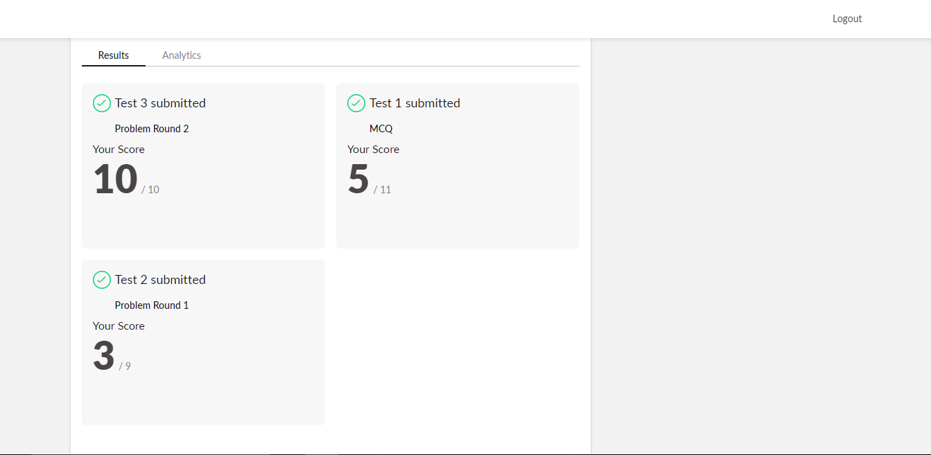

|  |  |  |  |
| --- | --- | --- | --- |
| **Certification Course Details** | | | |
| **Course** | **Blockchain Essentials** | | |
| **Certificate Provider** | **Cognitiveclass.ai** | **Duration** | **6 hours** |

**Encl : snapshots of the daily class acitivities (atleast two snap shots)**

**Progress on 27-05-2020**

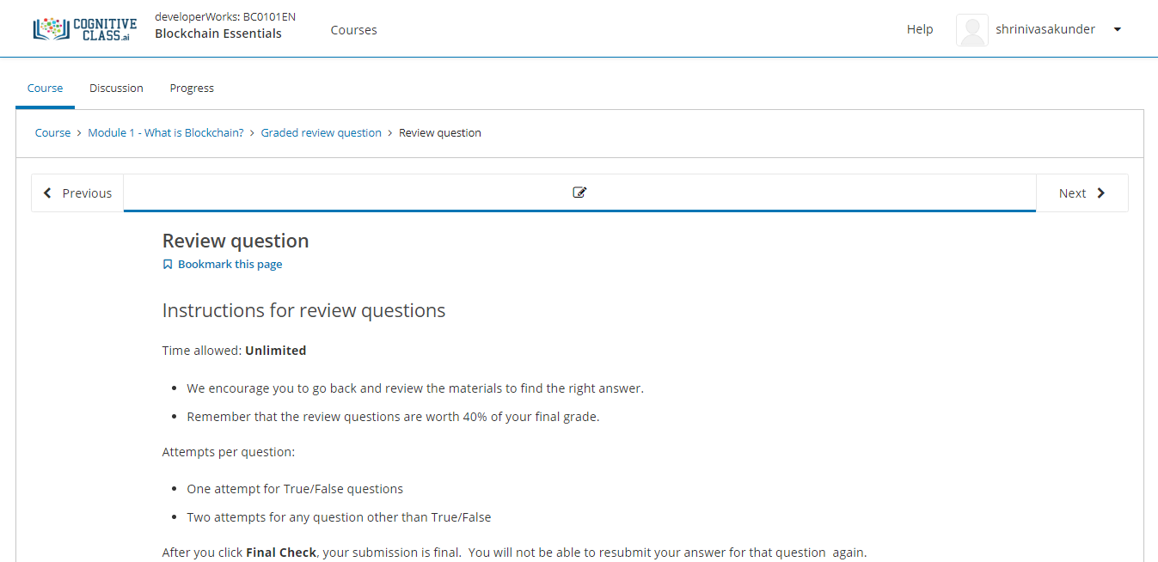

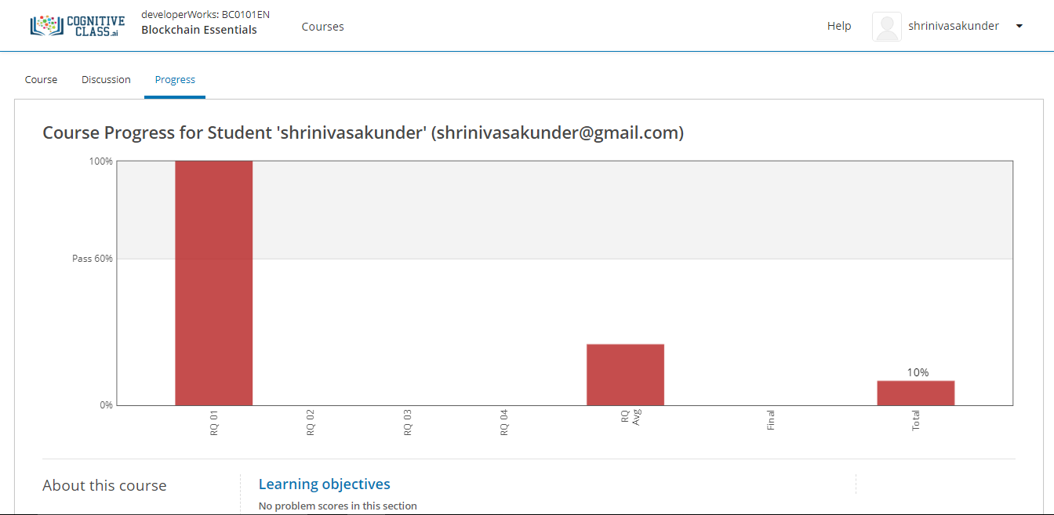

|  |  |
| --- | --- |
| **Coding Challenges** | |
| **Problem Statement: Pro1(java): The largest element on left side of each index of array.**  **Pro2(java): Binary tree using linked list. Pro3(c): No. of passes performed for bubble sort.** | |
| **Status: Completed** | |
| **Uploaded the report both in Github & Slack** | **Yes** |

**Encl : snapshots of your response to challenge.**

